SPECIAL CAMPS 2018-2020
NSS unit of Aragonda Apollo College of Nursing, Aragonda
Mrs.Chithra .B - NSS Programme Officer.

Our NSS Unit conducts many special camps in adopted villages. Basic survey done our volunteers. Elicited the need and problems of the selected village and life situations of the population and the along with Nature. Students volunteers involved in the camp by putting enormous hard work of organizing blood donation camp awareness programme, within the college premises in the village. It was effective among population. District Head quarters hospital, Chittoor supported in conducting blood donation camp successfully.
Sl.No. | Description | Date | Beneficiaries
1. | NSS special camp – Thodathara | 19.03.2018-25.03.2018 | 400
2. | NSS special camp on ODF - Venkampalli | Oct., 2018 | 250
3. | NSS special camp 2018 – Vengampalli | 21.2.2019 – 25.02.2019 | 450
4. | Blood Donation camp | 8th March-2017 | 25 units
5. | Blood donation camp | 18.03.2020 | 26 units

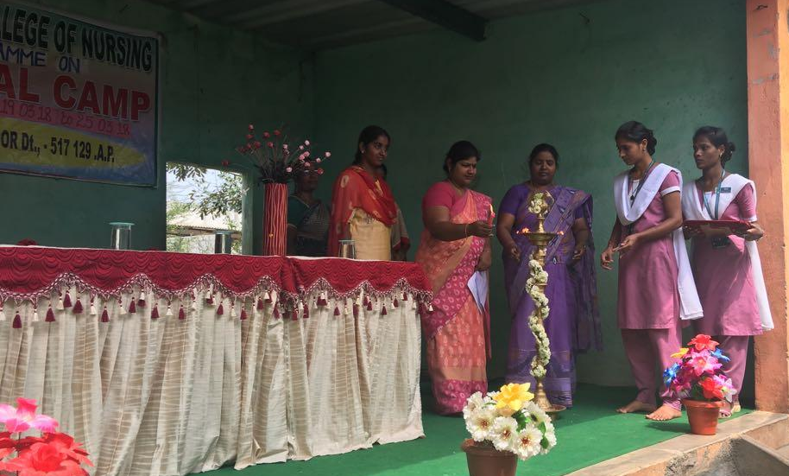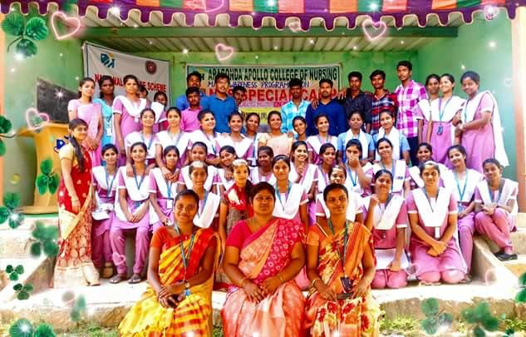
Fig-1 : NSS Special camp inauguration at Thodathara with all Volunteers.

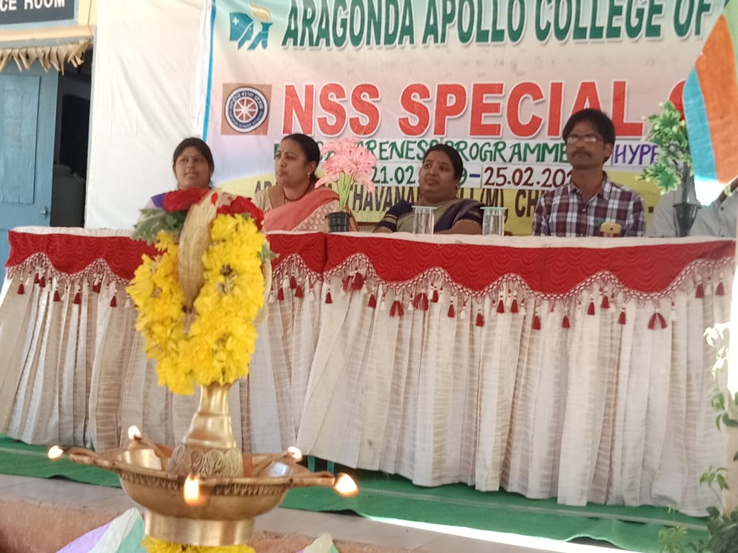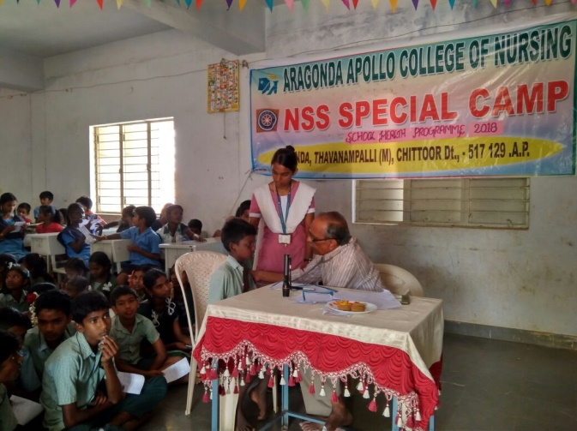
Fig-3 : NSS Special camp inauguration at Vengampalli and School health programme.
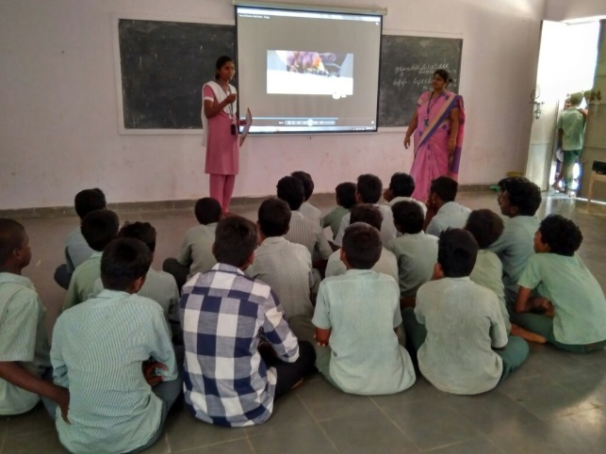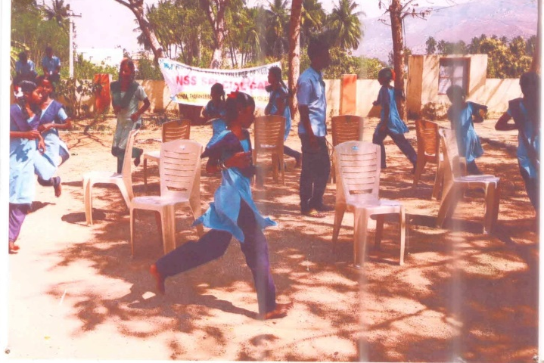
Fig-5 : NSS Special camp – Awareness on heat stroke and Sports conducted for school children.
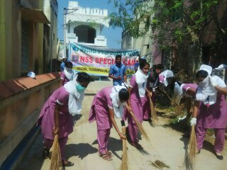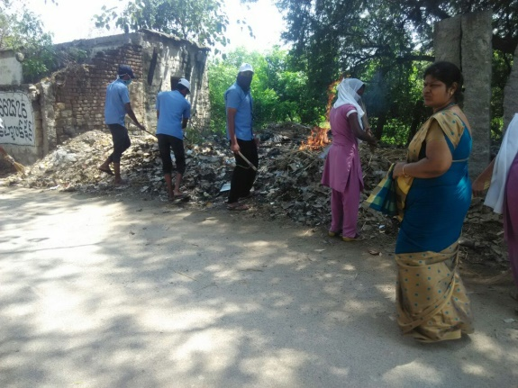
Fig-7 : NSS Special camp – Swachh Bharath
.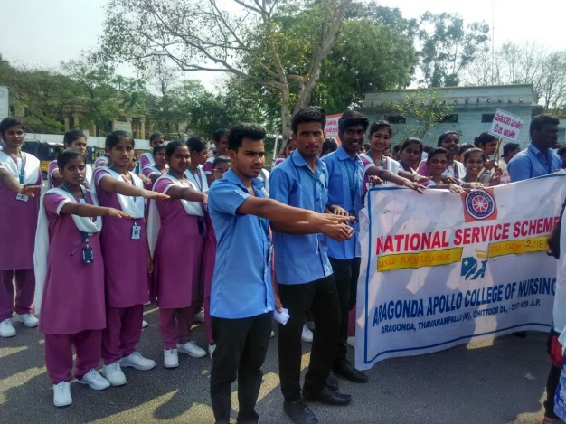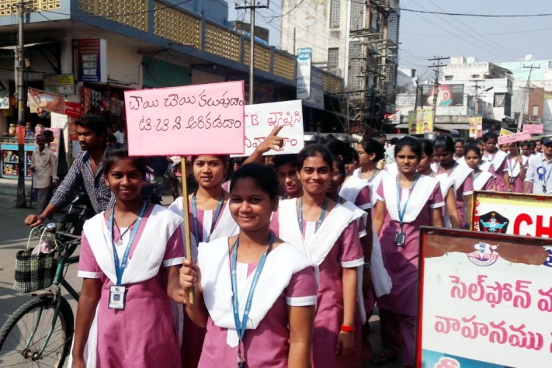
Fig-9 : NSS Special camp – TB day rally
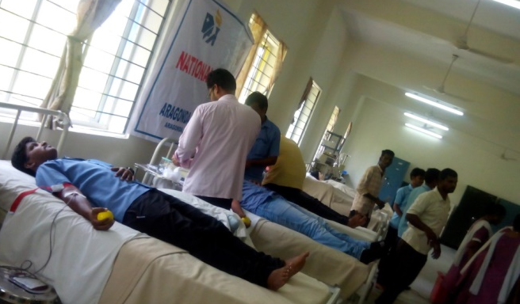
Fig-11 : NSS Special camp – Blood Donation – 18.03.2020 at AACON.

